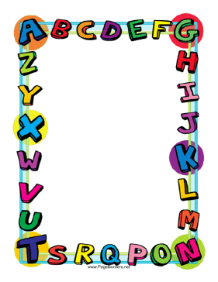

Let’s practice:

PET EXAM

PRACTICE

Here there are some links to web pages where you can practice on this topic.

* <http://www.englishaula.com/en/pet-exam-listening-cambridge-preliminary-english-test-video-lessons-practice-tests-exercises.php>
* <http://www.flo-joe.co.uk/preliminaryenglish/>
* <http://www.examenglish.com/PET/reading1.htm>
* <http://esl-bits.net/interact/sets/Set1_frame.htm>
* <http://esl-bits.net/interact/sets/Set1_frame.htm>
* <http://esl-bits.net/interact/sets/Set1_frame.htm>
* <http://esl-bits.net/interact/sets/Set1_frame.htm>
* <http://esl-bits.net/interact/sets/Set1_frame.htm>
* <http://olpt.s3.amazonaws.com/online-practice-pet/index.html>