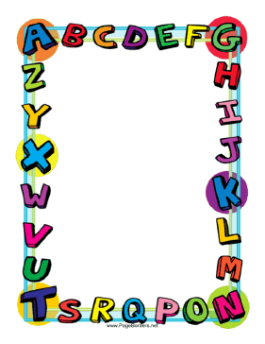

Let’s practice:

Present Simple

Here there are some links to web pages where you can practice on this topic.

**EXPLANATION**

* <http://www.aprenderinglesfacil.es/2008/03/presente-simple-simple-present-tense.html>
* <http://esl.fis.edu/grammar/rules/pressimp.htm>

**EXERCISES**

* <https://www.ego4u.com/en/cram-up/tests/simple-present-1>
* <http://www.really-learn-english.com/simple-present-exercises.html>
* <http://www.myenglishpages.com/site_php_files/grammar-exercise-simple-present.php>

**GAMES**

* <http://www.eslgamesplus.com/present-simple-tense-action-verbs-interactive-monkey-game/>
* <http://www.interactive.cambridge.org/media/games/level1/game2_astro/>
* <http://www.interactive.cambridge.org/media/games/level1/game4_robot/>